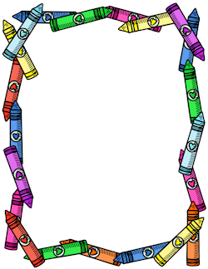

**Palmetto Youth Academy**

**Kindergarten**

**School Supply List**

**2018-2019**

**Crayons/16 count**

**Kindergarten Writing Tablet**

**4 Folders with 3 prongs**

**2 Packs of #2 Ticonderoga Pencils**

**Box of Sandwich bags**

**Box of Gallon Ziplock Bags**

**1 black/white composition notebook**

**Change of Clothes**

**Classroom Supplies**

**2 pks of copy paper**

**2 boxes of Kleenex**

**2 bottles of hand sanitizer**

**2pks of Clorox wipes**

**3 Rolls of Paper Towel**

**2 pks of Baby Wipes**

**2 cans of Lysol**